FSDI 105 – Assignment 1
Name: Charles Taggart
Theme: Register Services and Validate the Inputs
GitHub Pages Link: https://github.com/chucktagg83/project104.git

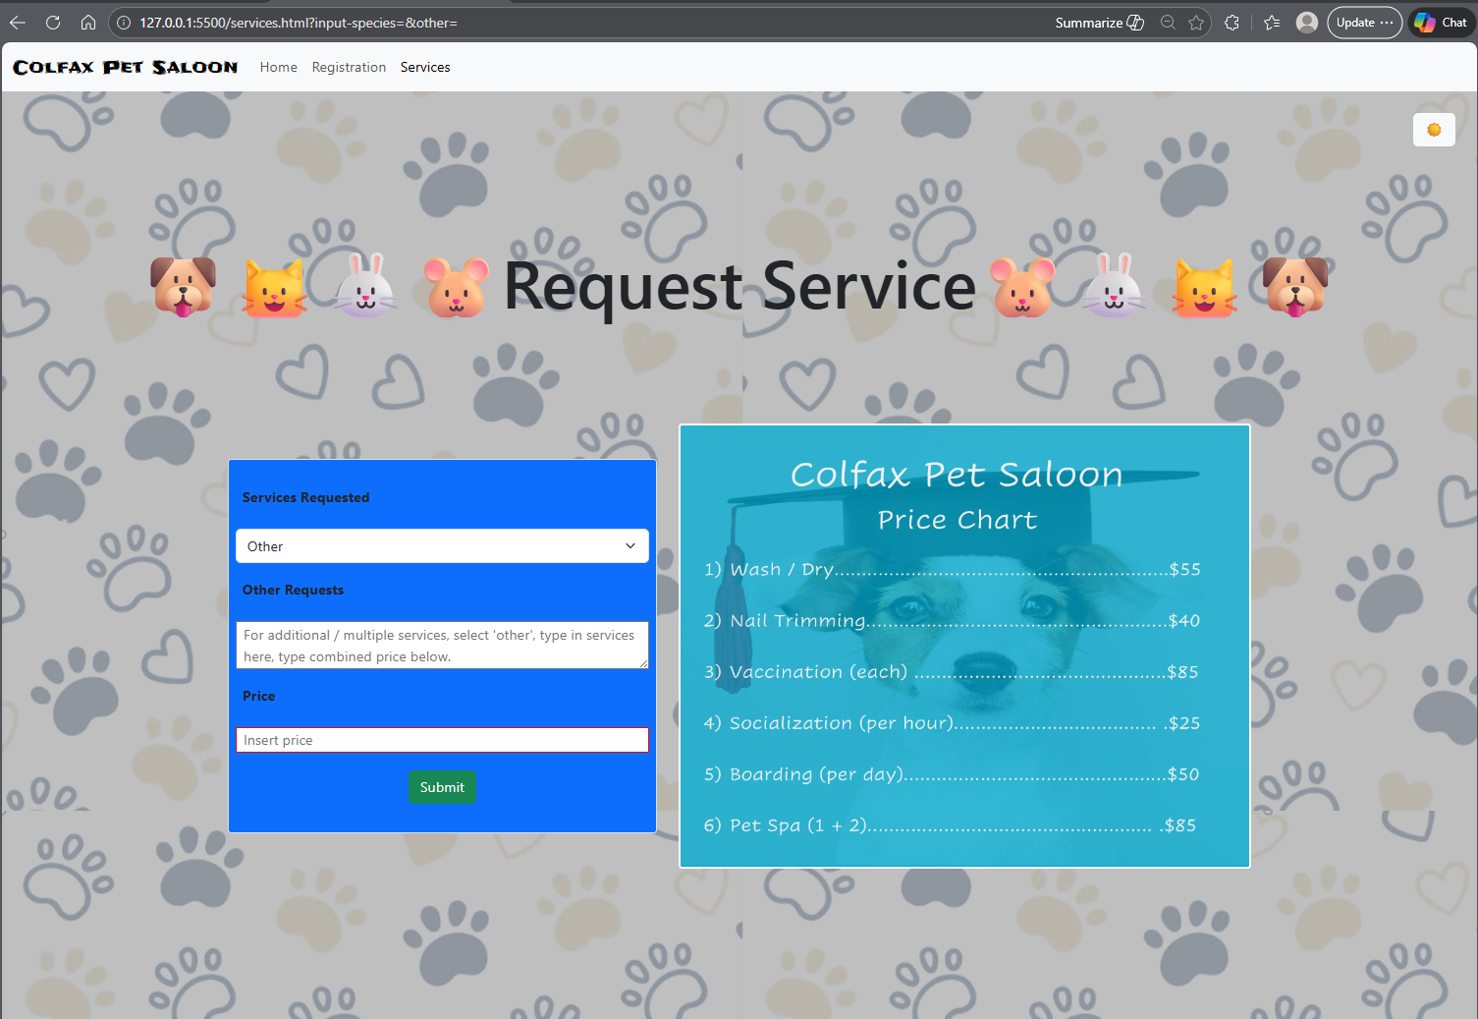
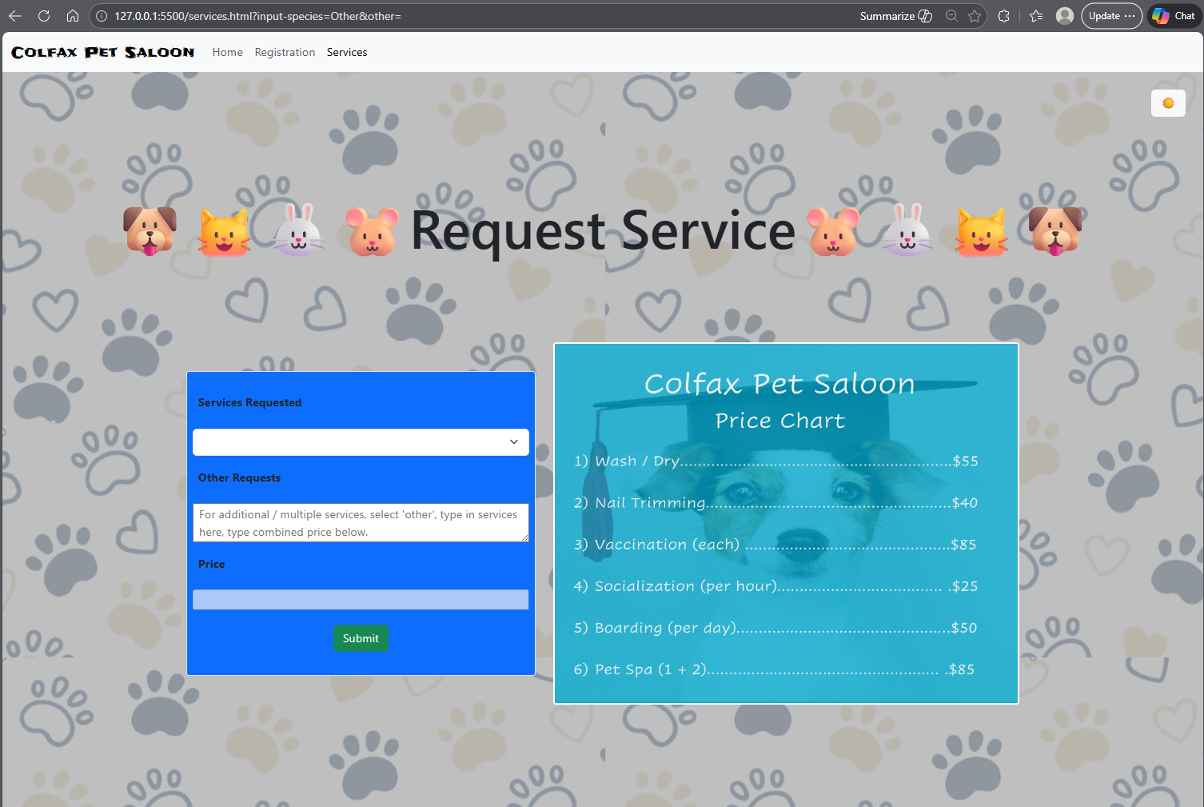

Summary of Edits:
- Created a form for service requests.
- Implemented a red border instead of an alert box for empty field.
- Allowed for to be reset and remove all borders.

